NORMAN VERSION VALIDATION PROCEDURE

Contents

Fork Norman Porject 3

Go to Norman/Norman 3

Click on ‘Fork’ button 3

Select your repository 3

Wait 4

Now you should have something like that “IXXXXX/Norman” 4

Click on ‘package.json’ and click on ‘Edit’ 5

Modify version of your test modules and commit 6

Clone Norman (need to be update) 7

Dependencies installation 12

Run an acceptance test (To be provided later on) 13

Pull request process: 14

Go to pull request of your repository 14

Create a pull Request 14

Check the modification and click on create a pull request 15

Add Comment if needed, and click on ‘Send pull request’ 16

Redirection to Norman/Norman 17

Clean your repo 18

Go to your repository 18

Open Setting 18

Click on ‘Delete this repository 18

Put the full name of your repository and click on ‘I understand the consequences, delete this repository’ 19

# Fork Norman Porject

## Go to Norman/Norman

<https://github.wdf.sap.corp/Norman/Norman>

## Click on ‘Fork’ button

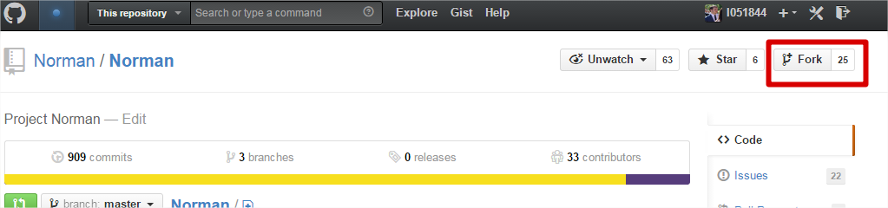

## Select your repository

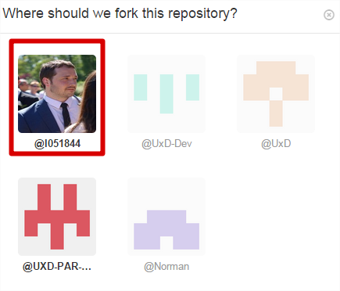

## Wait

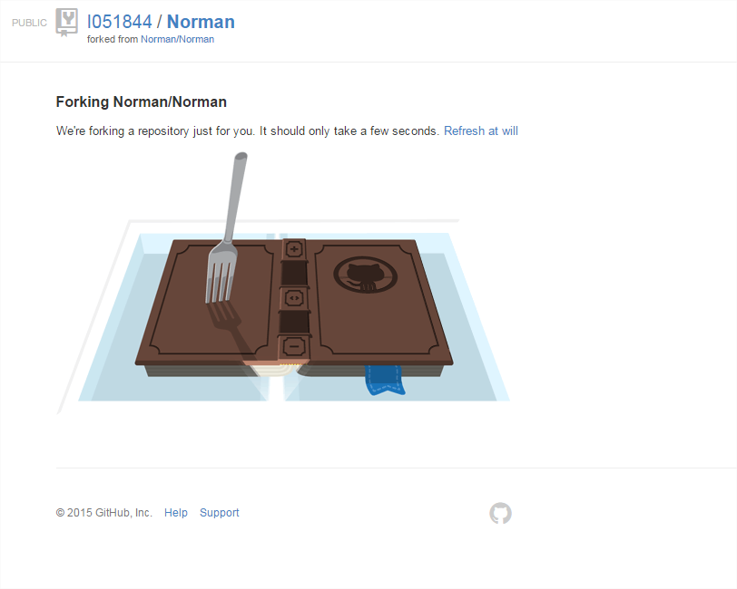

## Now you should have something like that “IXXXXX/Norman”

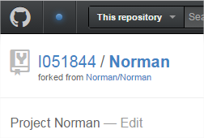

## Click on ‘package.json’ and click on ‘Edit’

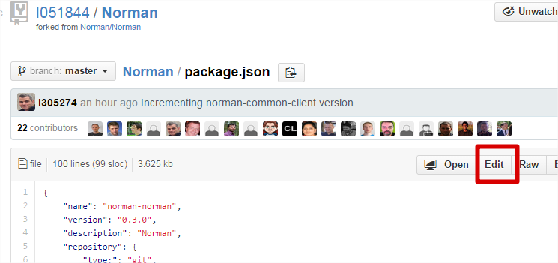

## Modify version of your test modules and commit

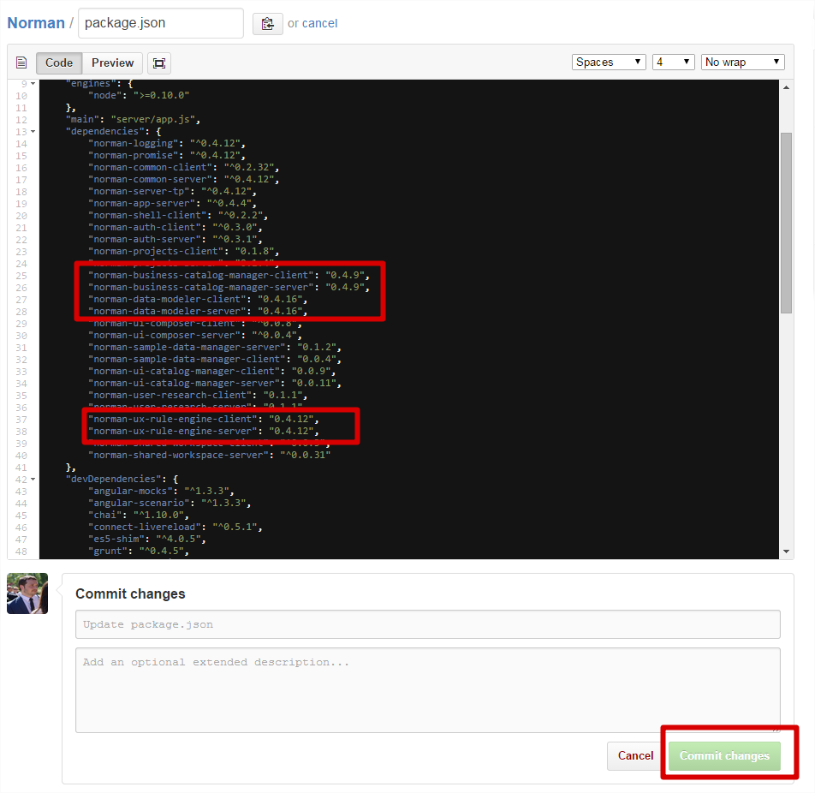

# Clone Norman

Create a new directory NormanProject our Norman project

example <https://github.wdf.sap.corp/I051844/Norman.git>

Go to IntelliG or Webstorm

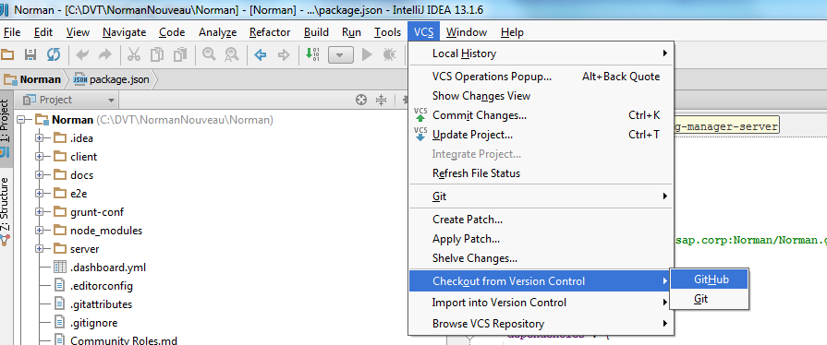

Select in Repository URL the ***Inumber*** /Norman.git

In Parent Directory, enter the path to the directory you have already created “Norman”

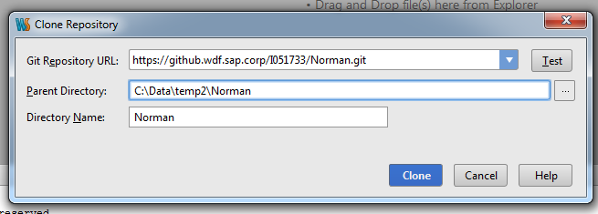

Click on CLONE

On WebStorm

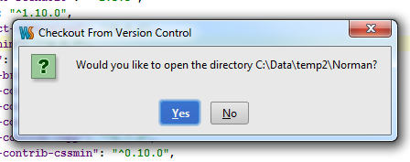

Click on Yes

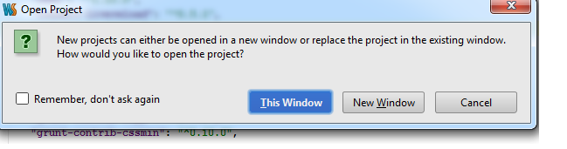

Click on New Window

On IntelliG

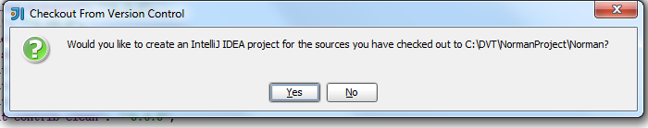

Click on Yes

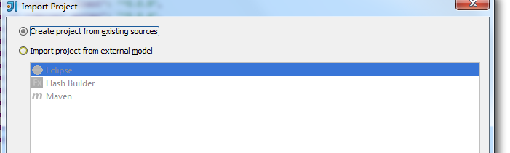

Create project and click on Next

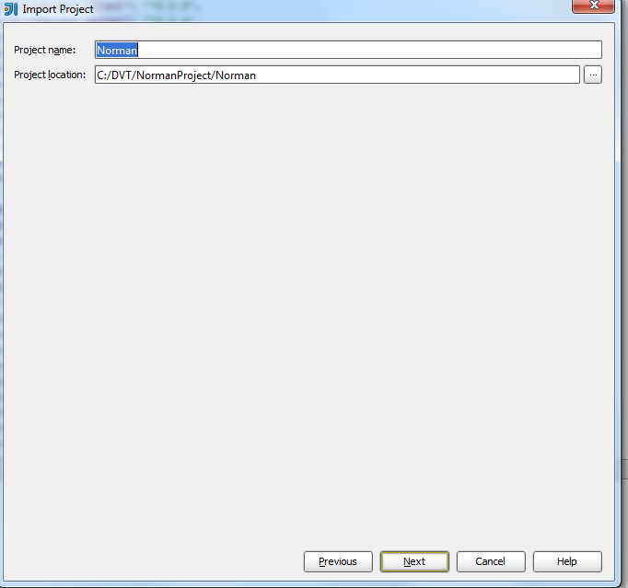

Click on Next

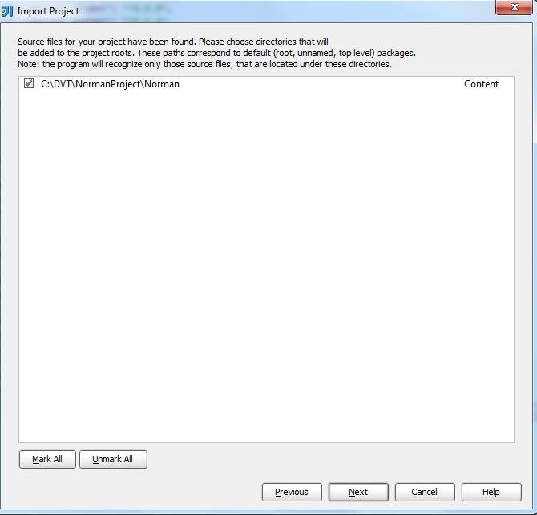

Click on Next

And after that on Finish

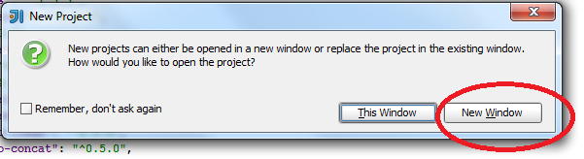

Click on New Window

Click on Terminal tab and enter the following commands

# Dependencies installation

npm cache clean

npm install

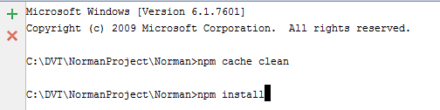

# Run an acceptance test (To be provided later on)

# **Pull request process**:

## Go to pull request of your repository

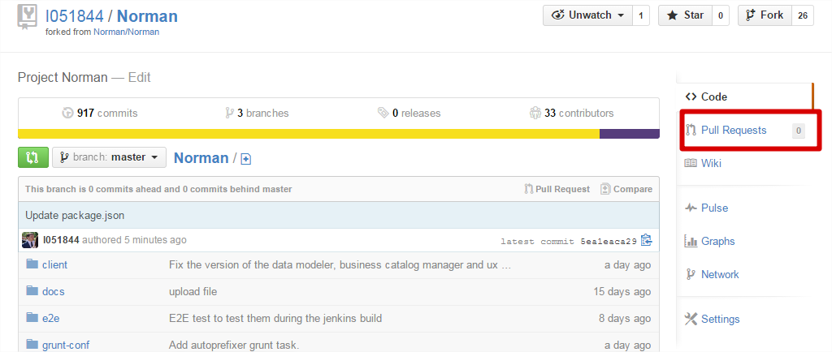

## Create a pull Request

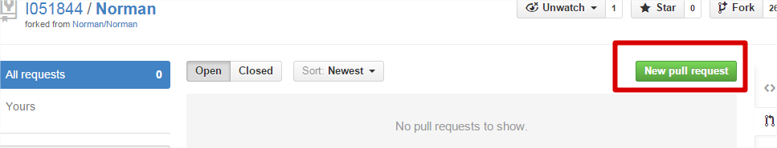

## Check the modification and click on create a pull request

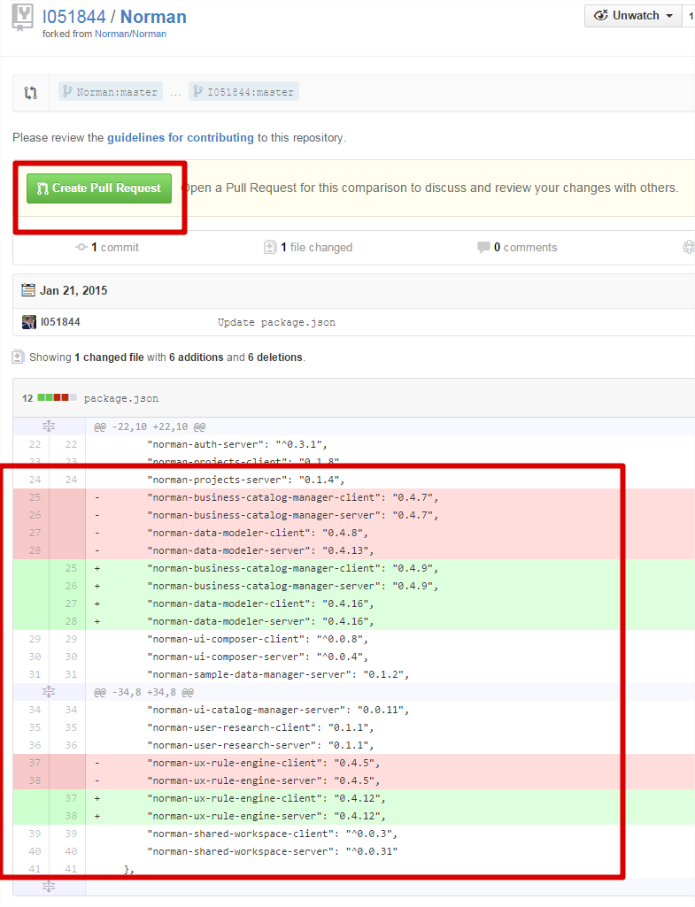

## Add Comment if needed, and click on ‘Send pull request’

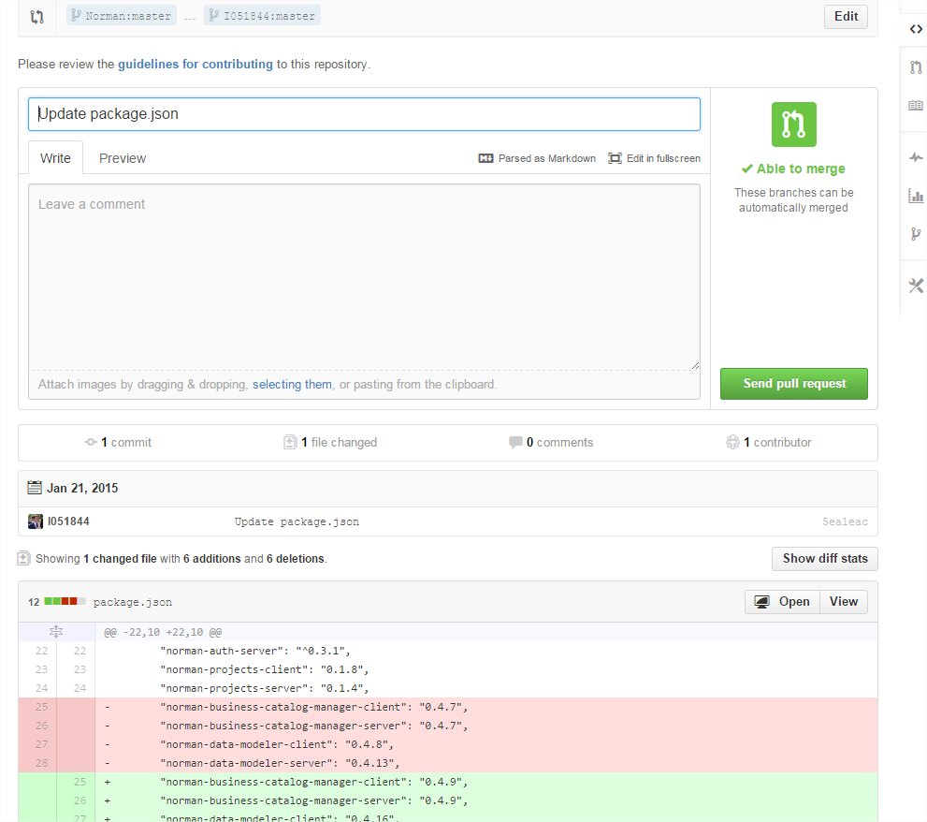

## Redirection to Norman/Norman

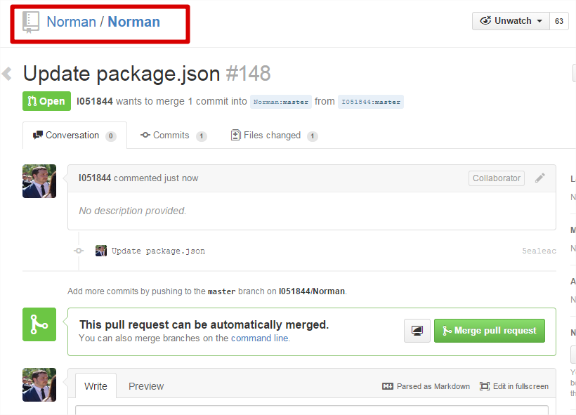

# Clean your repo

## Go to your repository

Example:

<https://github.wdf.sap.corp/I051844/Norman>

## Open Setting

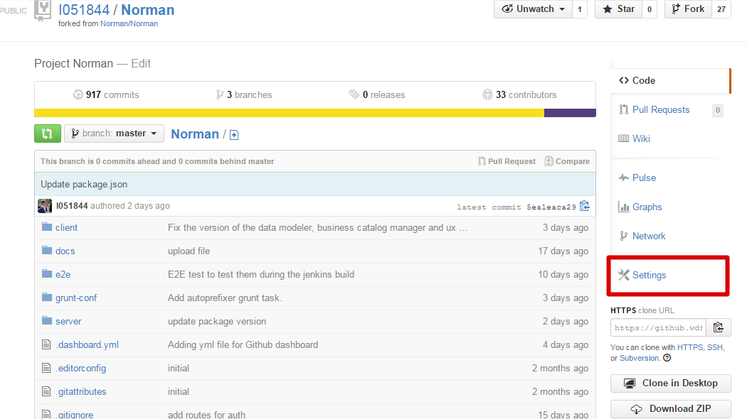

## Click on ‘Delete this repository

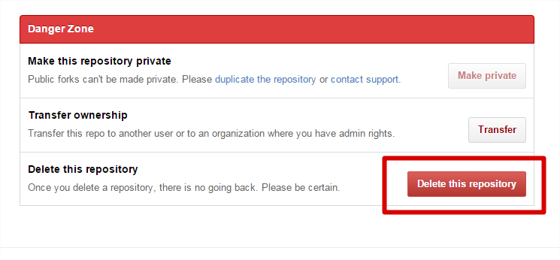

## Put the full name of your repository and click on ‘I understand the consequences, delete this repository’

